Environment Scan Assignment

The maternal and child health indicators I found in Memphis, Tn Shelby county are Uninsured adults, Uninsured children, Teen births, Low birth rates and Infant mortality.

Visualization of indicators between Shelby County, Tennessee State and National

Uninsured adults and Uninsured children

Teen Births and Low Birth Rates

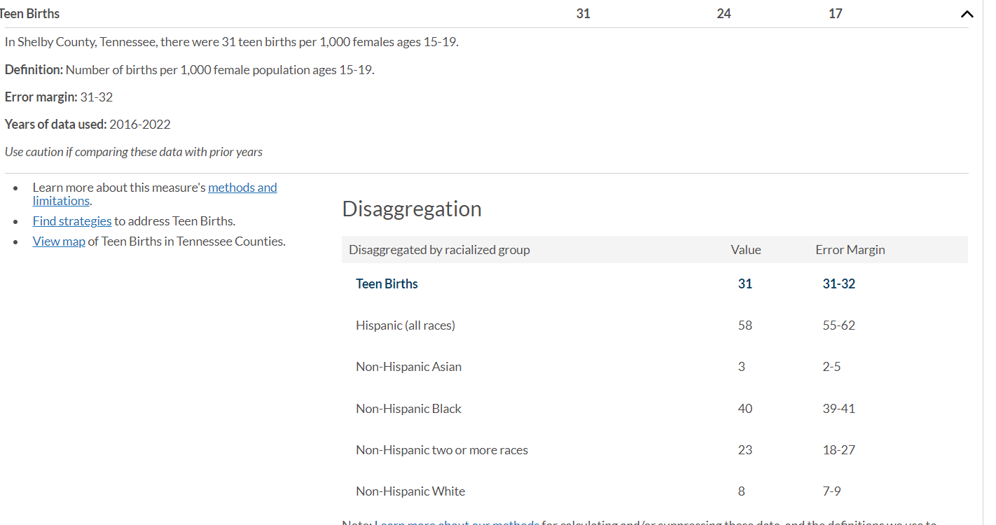

Infant Mortality

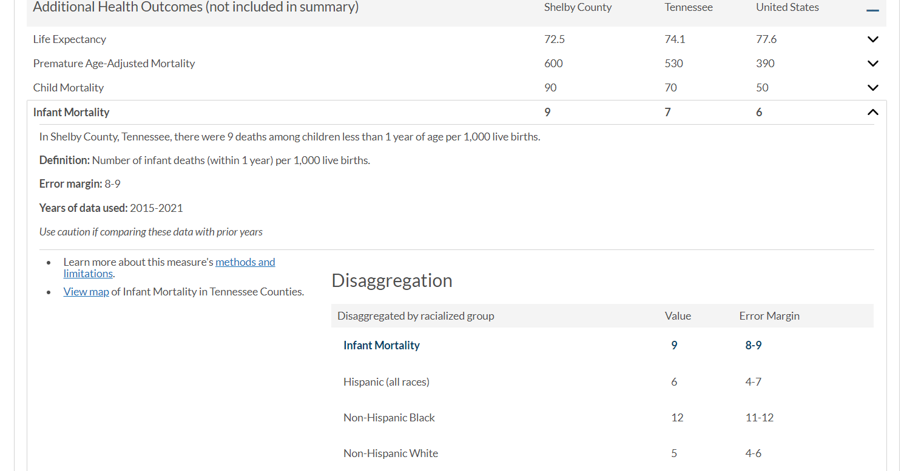

Visualization of Shelby County Demographics

Visualization of indicators between Baltimore City, Maryland State and National

Uninsured Adults and Uninsured Children

Teen Births and Low birth rates

Visualization of Baltimore City demographics

Analyze and Comparison interpretation of data.

Demographically, the non-Hispanic White population is significantly more significant in the state of Tennessee than in the state of Maryland. This stark contrast in demographics, particularly the larger population of people of color in Shelby County and the city of Baltimore, underscores the significant demographic differences between the two regions.

       In contrast, from 2016-2022, Shelby County and Baltimore City have significantly different percentage values for uninsured adults, uninsured children, and teen births. Shelby County's uninsured adults’ percentage is double (16%) that of Baltimore City and is four times the percentage of the national percentage value. Also, Shelby County's percentage of uninsured children is higher than that of Baltimore City, but it is equal to the national value. Surprisingly, Baltimore City's percentage (28%) has a small significant difference percentage than Shelby County's (31%), but both teen birth percentages are larger than the National 17 percent.

       Despite the disparities, there are areas where Shelby County and Baltimore show similarities. From 2016 to 2022, both regions had a similar percentage value of low birth rates. This similarity, particularly in the demographics of the non-Hispanic Black population, with a 15-16 percent value, and non-Hispanic American Indian and Alaskan Native, with a 14 percent value, provides a glimmer of hope amidst the disparities.

Furthermore, infant mortality is 15 percent value for non-Hispanic Black people compared to non-Hispanic Whites 4 percent value. Surprisingly, Baltimore City and Shelby County infant mortality is significantly higher than the national percentage of infant mortality.

Problem statement

The lack of healthcare mother access for the demographic population of color can significantly increase the decline in health outcomes and mortality rates. The above statement is a general observation hypothesis. To dive deeper into the disparities or understand the pathway to the increase in mortality rates among this demographic population, I must ask why. For example, why is having access to healthcare linked to maternal mortality? Does it matter what kind of healthcare provider? Should the healthcare provider be of the same race, sex, or spiritual beliefs as the mother?

In contrast to the uninsured, Does it matter what kind of healthcare insurance the mother has: state, private, or no insurance? If the mother has medical access, do they trust the healthcare system? Are mothers well educated on the birthing process and maternal or maternal health in general? Is the access to care or the type of care linked to the increase in maternal mortality? Utility, I desire to answer the question of what disparities connect the proper pathway of maternal mortality in the Shelby County population of colored demographics.

Data Source Citation

https://www.countyhealthrankings.org/